Installation of Motosuiveur® on existing hoist
Technical description :

- Zero modification to existing barrels
- Compact design
- Low height of axis
- Easy deactivation (for maintenance, etc.) by removing the worm gear

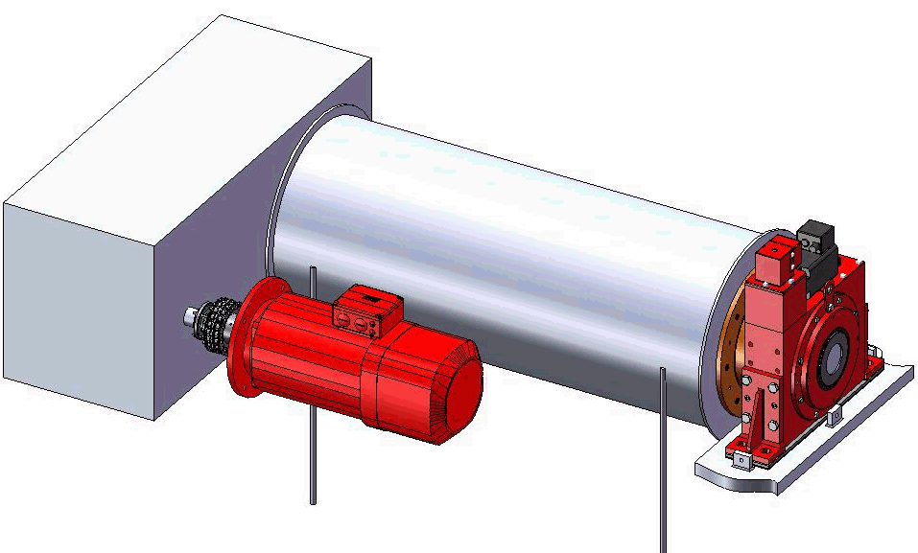
Under this cover,
Crank shaft for manual
operation and recovery
Existing drum:
no modification
Motosuiveur® (MS)
Passive friction bearing version
Existing drum shaft:
no modification
Safety Torque limiter (option)
Existing Gearbox,
Motor & Brake:
no modifications
Motosuiveur Transmission Flange:
- fixed to Motosuiveur®,
- centered with the existing shaft,
- pinned to the drum with dowels,
- Accepts any geometric imperfection of the side flange of the drum

APPENDIX

Additional explanations
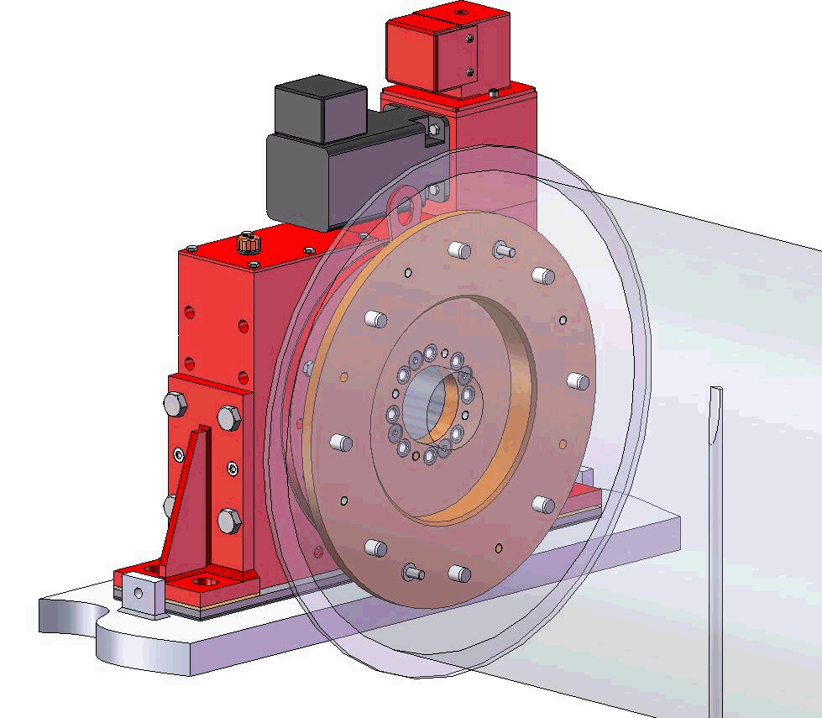
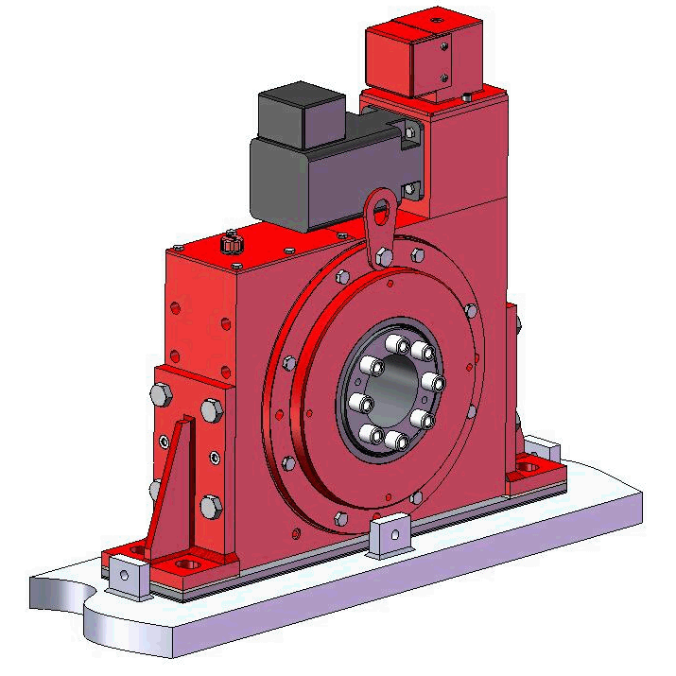
Dowels between flange/drum (for torque transmission)
2 bolts between flange/drum
(to attach flange to drum)
Dowels between flange/MS (for torque transmission)
bolts between
flange/MS
(to attach flange to MS)
Fitted assembly between MS wheel and drum shaft
Minimum height
(height of the MS)
Shims for height adjustment

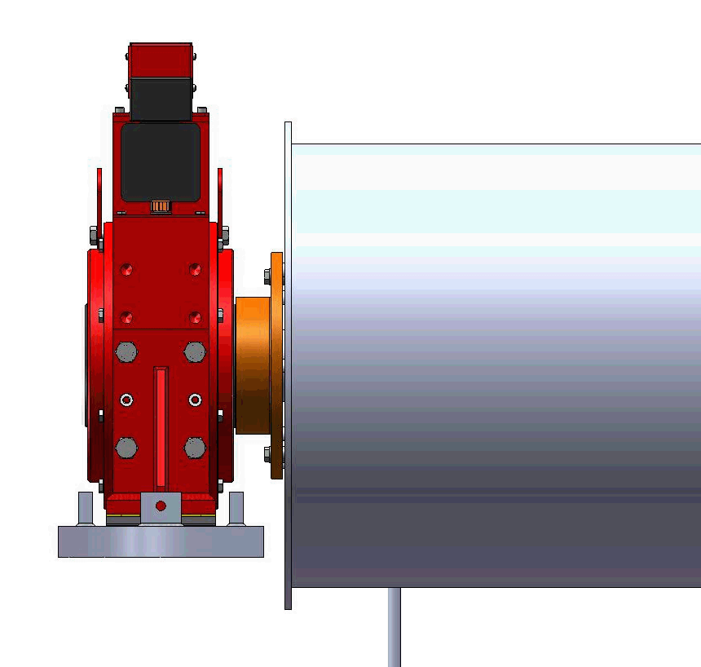

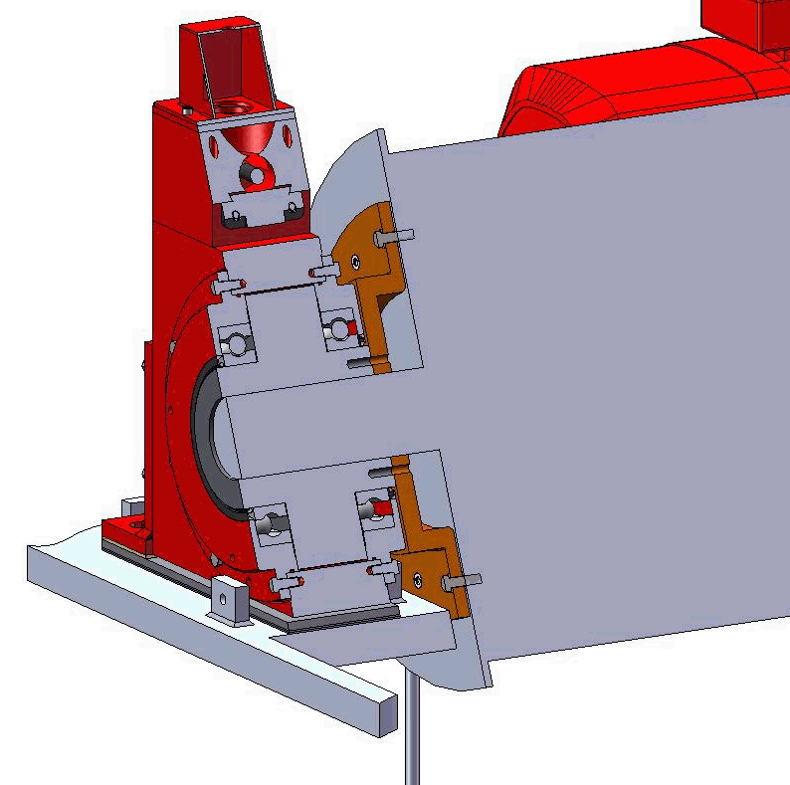
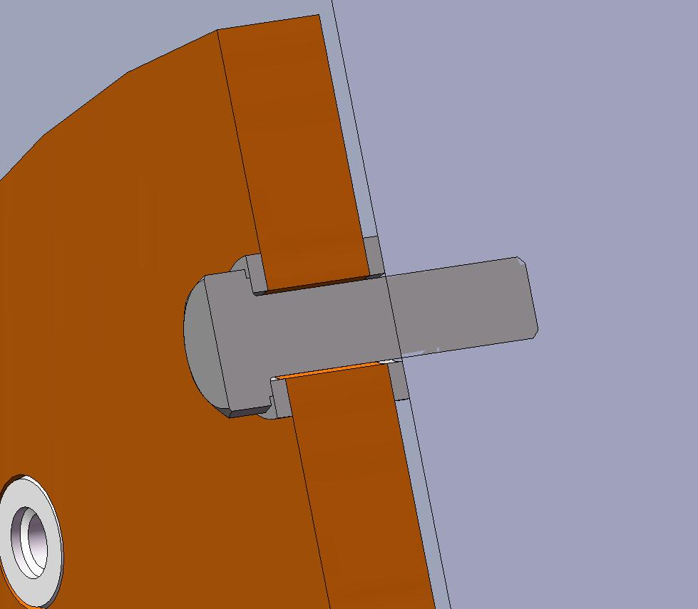
Washer (allow to be strictly aligned with the barrel axis)
2 points on the barrel side that are on the same axial plan

Installation :

- Prior to remove the existing plummer block, make one rotation and find by comparator the 2 points on the barrel side flange that are on the same axial plane on the diameter of the future pin and bolts diameter. These two points will receive the bolt holes,
- Remove the existing plummer block,
- Put the transmission flange on the barrel shaft (fitted assembly) and use the holes to counter-drill holes on the barrel side flange,
- Mount the transmission flange on the MS wheel (bolts, pins),
- Assemble the flanged MS to the side flange of the barrel. The washers create a gap which allows the MS to be strictly aligned with the barrel (shaft) axis. The MS wheel and flange are fitted to the existing barrel shaft so the MS is strictly concentric to the barrel.

Thus :

- The vertical load is taken by the shaft, as before, but the transmission flange helps also,
- The bolts are just holding the parts together, practically no forces to transmit,
- In case of braking, all the torque is transmitted to the barrel via the pins,
- The transmission flange creates a redundant load path, so the « shaft break » scenario becomes highly improbable

